SYSC 4805 Computer Systems Lab

Title: Snow Plow Project Progress Report

Lab Section: L2 - Group 4

Date: Feb 28th 2022

Group Members:

| Name | Student Number |
| --- | --- |
| Huzaifa Mazhar | 101071739 |
| Leenesh Kumar | 101115874 |
| Will Brooks | 101075150 |
| Alex Tasseron | 101067304 |

**PROJECT CHARTER:**

**OBJECTIVE:**

The objective of our project is to create a mobile robot which can operate as a snowplow. The robot will attempt to remove all snow from a simulated area and create a clear path.

**DELIVERABLES:**

The purpose of the project is to design and implement a robot in Coppeliasim to clear snow from an enclosed area. The design of the robot must adhere to the physical specifications (size, starting position, speed) outlined in the project description. Any sensors mounted to the robot must be realistic and have a corresponding link to the real-world vendor of a similar sensor for documentation purposes. External programming libraries are allowed to help automate the robot, however augmentation of the main script is prohibited. Additionally, the robot must operate in an enclosed area defined by a black line during simulation. Ideally, this task should be accomplished such that the maximum amount of snow is cleared and the minimum number of collisions with obstacles occur within a given timeframe. Success is measured by the number of ‘snow balls’ cleared by the robot. A deduction of 20 snowballs is assessed anytime the robot collides with an obstacle. The robot will be tested on 3 testing maps and must be able to run for the entire 5-minute duration of the simulation. Design, testing, and grading of the robot will be completed by April 12.

Scope:

**List of Requirements:**

Listed below are the requirements that the robot must adhere, as outlined in the project documentation.

1. The robot must fit within a volume of 0.5 m x 0.8 m x 1 m when parked
2. The robot’s volume must not exceed 1 m x 0.8 m x 1 m at any time during the simulation.
3. The robot must navigate the testing area without getting stuck for the duration of the simulation
4. The robot must not leave the testing area during operation for the duration of the simulation
5. The robot must not collide with obstacles in the testing area for the duration of the simulation
6. The robot must remove the snow from the testing area using a plow. Snow cannot be blown out of the area.
7. The robot must not exceed 2 m/s during the simulation.

**Work Breakdown Structure:**

The following WBS structure is a decomposition of all the AOIs(Areas of Interest) for our project. From each branch is a description of every activity that pertains to that AOI. This WBS is an integral part of our project as it covers the entire scope and the desired deliverables at the end.

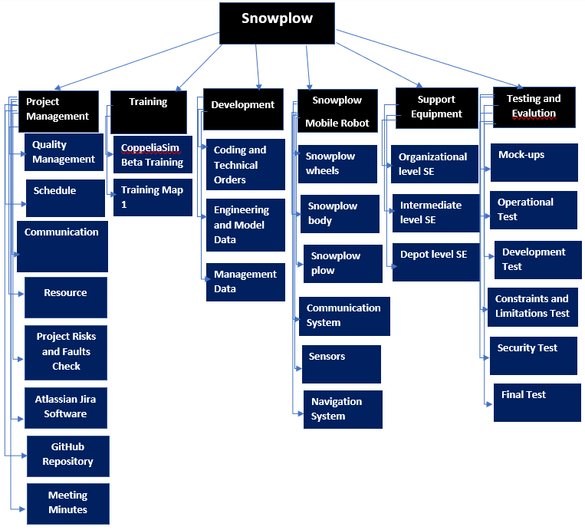

Figure 1: Work-Breakdown-Structure diagram for the SYSC4805 Snow plow lab project

**Testing:**

The proposed acceptance tests for the project may be seen in the table below. Successfully completion of the project depends on all acceptance tests being passed.

| Test Number | Tested Require-ment(s) | Test Procedure | Pass/Fail Conditions |
| --- | --- | --- | --- |
| 1 | 1 | Measure the x, y, and z dimensions of the robot in parked configuration. | If the dimensions are less than the maximum then the test passes.  If not the test fails |
| 2 | 2 | Measure the x, y, and z dimensions of the robot in the configuration that maximizes each dimension. | If the dimensions are less than the maximum then the test passes.  If not the test fails |
| 3 | 3 | Begin simulation. Allow the robot to navigate the testing area for 5 minutes. | If the robot gets stuck within the time the test fails.  If the robot does not get stuck within the time, the test passes. |
| 4 | 4 | Begin simulation. Allow the robot to navigate the testing area for 5 minutes. | If the robot leaves the testing area during the simulation time the test fails.  If the robot remains within the testing area during the time the test passes. |
| 5 | 5 | Begin simulation. Allow the robot to navigate the testing area for 5 minutes. | If the robot collides with an obstacle during the simulation time the test fails.  If the robot does not collide with an obstacle during the simulation time, the test passes |
| 6 | 6 | Begin simulation. Allow the robot to navigate the testing area for 5 minutes. | If snow is removed from the testing area using only a pushing action from the robot the test passes.  If snow is removed from the area using any action other than pushing the test fails. |
| 7 | 7 | Begin simulation. Allow the robot to navigate the testing area for 5 minutes. Measure the speed of the robot during the simulation. | If the speed exceeds 2 m/s then the test fails.  If the speed does not exceed 2 m/s then the test succeeds |
| 8 | 7 | Calculate the maximum speed of the robot based on wheel size and angular velocity. | If the calculated speed exceeds 2 m/s the test fails.  If the calculated speed does not exceed 2 m/s the test passes. |

Table 1: Tests that need to pass to meet functional requirements of project

# Scheduling:

The schedule has been created to allocate each group member one activity to complete for each lab week. There are a total of 28 activities amongst four members. Each activity is designed and compartmentalized to take approximately one week so that it neatly coincides with the weekly lab schedule.

**List of activities:**

Format

[lab #]:

[activity #] - [assignee] - title and description - est time required

Lab4 (starting week of February 4th):

Activity 1 - Huzaifa - Iteration 1 of snow plow design option 2 - 1 week

Activity 2 - Will - Iteration 1 of snow plow design option 1 - 1 week

Activity 3 - Leenesh - Work on training map 1 - 1 week

Activity 4 - Alex - Investigate obstacle detecting sensors/camera and collision avoiding methods - 1 week

Lab5:

Activity 5 - Huzaifa - Iteration 2 on snow plow design option 2 + testing effectiveness - 1 week

Activity 6 - Will - Iteration 2 snow plow design option 1 - 1 week

Activity 7 - Leenesh - Test and implement line-following till faultless - 1 week

Activity 8 - Alex - Iteration 1 of implementing obstacle detection and collision avoidance in CoppeliaSim - 1 week

Lab 6:

Activity 9 - Huzaifa - Iteration 3 on snow plow option 2 + testing effectiveness at snow removal - 1 week

Activity 10 - Will - Iteration 3 on snow plow option 1 and test effectiveness at snow removal - 1 week

Activity 11 - Leenesh - Collect data on the two snow plows and analyze the effectiveness of the two plow options - 1 week

Activity 12 - Alex - Iteration 2 of implementing obstacle detection and collision avoidance - 1 week

Lab 7:

Group Task: Select best snow plow option.

Activity 13 - Huzaifa - Integrate best snow plow to the body. Test all components to ensure functionality - 1 week

Activity 14 - Will - Integrate best snow plow to the body. Test all components to ensure functionality - 1 week

Activity 15 - Leenesh - Run simulation with integrated robot and identify faults/incomplete requirements - 1 week

Activity 16 - Alex - Integrate the sensors to the final robot - 1 week

Lab 8:

Activity 17 - Huzaifa - Snow plow scenario simulation testing - 1 week

Activity 18 - Will - Snow plow simulation testing - 1 week

Activity 19 - Leenesh - Analyze cause of any faults in the simulation testing - 1 week

Activity 20 - Alex - Revise and fine-tune collision avoidance code - 1 week

Lab 9:

Activity 21 - Huzaifa - Run simulation test 1 through 4 - 1 week

Activity 22 - Will - Implement any needed changes based on Leenesh's findings from lab 8 - 1 week

Activity 23 - Leenesh - Identify edge cases in simulation testing and anything else that doesn’t meet the functional requirements for the robot - 1 week

Activity 24 - Alex - Run simulation tests 4 through 8 - 1 week

Lab 10:

Activity 25 - Huzaifa - Final simulation testing - 1 week

Activity 26 - Will - Final simulation testing - 1 week

Activity 27 - Leenesh - Identify and record any functional requirements not met - 1 week

Activity 28 - Alex - Demonstration practice runs - 1 week

## Schedule Network Diagram:

The schedule network diagram lists an activity for each member for each lab week, and displays any dependencies an activity may have. The activity descriptions can be found listed above. The date format is dd/mm/yyyy.

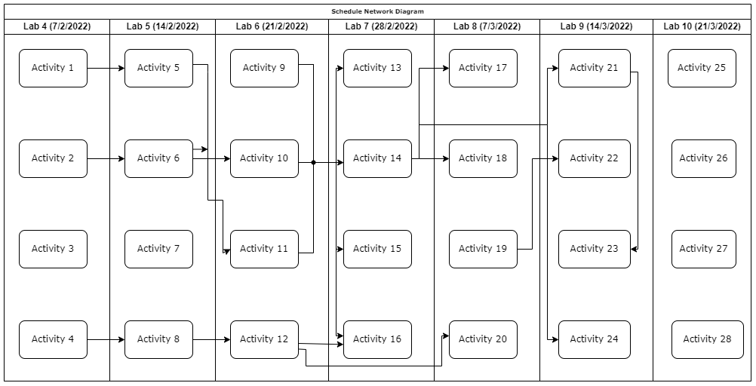

## Figure 2: Schedule Network Diagram and dependencies for planned weekly activities

## GANTT CHART:

The Gantt chart below displays the duration for each activity over the course of the project.

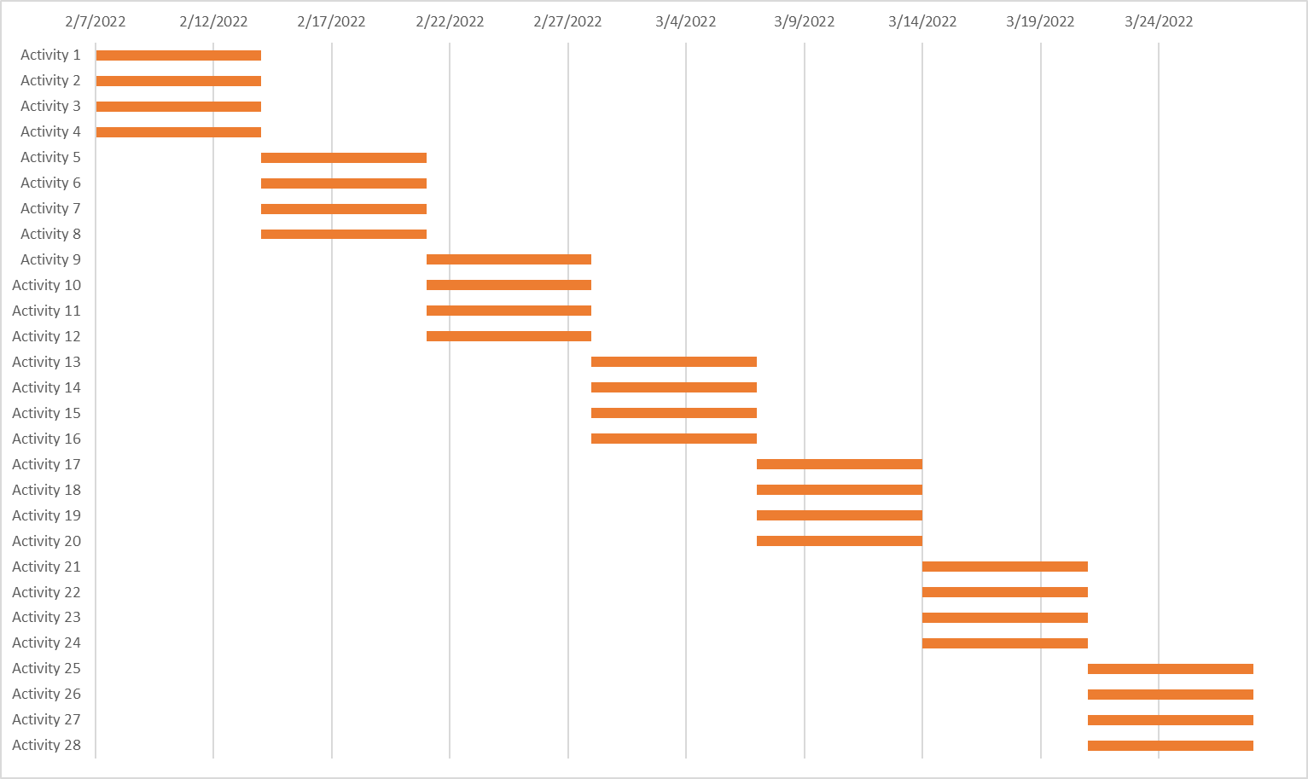

# Figure 3: Gantt chart displaying duration of each activity

# Human Resources:

## Responsibility Assignment Matrix:

The activities required to complete the project have been organized into the Responsibility Assignment Matrix below. The Activity Number corresponds to the ones found in the Scheduling section of this document. Each group member has seven activities that they are assigned to complete, and seven activities for which they are responsible. Due to the nature of working with such a small team, all members will be informed of, and consulted on each activity, so these notations have been omitted from the matrix. The label “R” denotes a member is Responsible for an activity. The label “A” denotes a member is Accountable for an activity.

| Activity Number | Alex | Huzaifa | Leenesh | Will |
| --- | --- | --- | --- | --- |
| 1 | R | A |  |  |
| 2 |  |  | R | A |
| 3 |  | R | A |  |
| 4 | A |  |  | R |
| 5 |  | A | R |  |
| 6 | R |  |  | A |
| 7 |  | R | A |  |
| 8 | A |  |  | R |
| 9 | R | A |  |  |
| 10 |  |  | R | A |
| 11 |  | R | A |  |
| 12 | A |  |  | R |
| 13 |  | A |  | R |
| 14 |  | R |  | A |
| 15 | R |  | A |  |
| 16 | A |  | R |  |
| 17 |  | A |  | R |
| 18 |  | R |  | A |
| 19 | R |  | A |  |
| 20 | A |  | R |  |
| 21 | R | A |  |  |
| 22 |  |  | R | A |
| 23 |  |  | A | R |
| 24 | A | R |  |  |
| 25 |  | A | R |  |
| 26 | R |  |  | A |
| 27 |  |  | A | R |
| 28 | A | R |  |  |

Table 2: Responsibility Assignment Matrix

# Overall Architecture

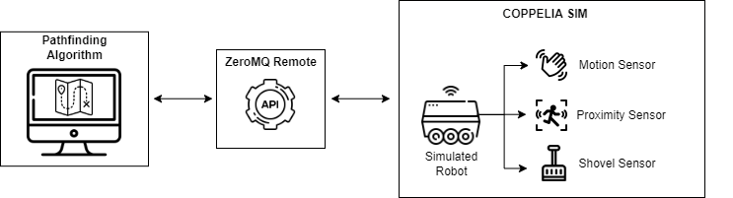

The simulated snow plow robot in Coppelia SIM uses the ZeroMQ Remote API to give and receive information. The pathfinding algorithm takes information from the API to determine the best path and then sends it back to the robot to execute.

# 

# State Chart

The statechart representing the project can be seen below. The system is event driven. This allows for the system to respond to external events quickly and reduces the amount of processing being done. If the robot were to be implemented in hardware this would result in lower power consumption. These power savings come at the cost of less predictable operation, however, since there are few system inputs and few system states, this is not expected to be a major issue.

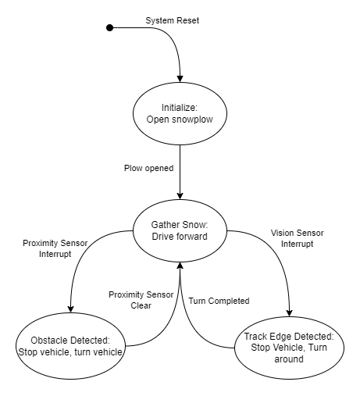

A potential solution being investigated for collision avoidance is Simultaneous Localization And Mapping (SLAM). Below is a generalized flowchart for using SLAM. The algorithm works by constantly updating a model of the world using sensor data, and using landmarks to localize itself in the map. This can be designed to be event driven and trigger certain actions. If the sensor data detects certain input, which will cause an interrupt.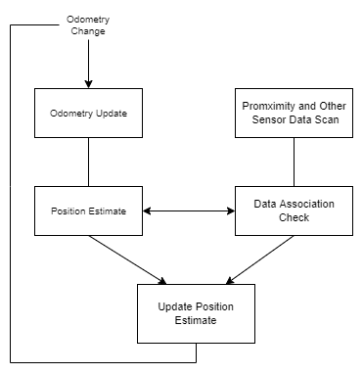

# 

# 

# 

# 

# 

# 

# 

# 

# 

# 

# 

# Sequence Diagram

The following sequence diagram presents the ideal use-case of the system, where the robot is initialized, plows some snow, detects an obstacle, and circumnavigates it.

# 

# 

# 

# Project Budget

The project is expected to have a Budget at Completion of about $3600 total. $2800 of that is engineering costs and about $820 is materials costs. Over the course of the seven week project, four hours are budgeted for each of the four team members. A cost of $25 per engineering hour was used to get this number.

Materials cost breakdown can be seen in the table below.

| Components | Number Required | Unit Cost ($) | Total Cost ($) | Supplier Link |
| --- | --- | --- | --- | --- |
| Raspberry Pi 0 Kit (includes camera and two servos) | 1 | 117 | 117 | <https://www.digikey.ca/en/products/detail/sparkfun-electronics/KIT-16327/12715013> |
| IMU | 1 | 14 | 14 | <https://www.sparkfun.com/products/10937> |
| Proximity Sensor | 1 | 4.5 | 4.5 | <https://www.sparkfun.com/products/15569> |
| 3D printer filament | 1 | 35 | 35 | <https://www.amazon.ca/DURAMIC-3D-Filament-1-75mm-Black-1/dp/B095HRG913/ref=sr_1_2_sspa> |
| Motors | 2 | 325 | 650 | <https://www.robotis.us/dynamixel-xm430-w210-t/> |

Since the robot will not actually be manufactured the materials costs will not be spent. Currently two weeks of project work have been completed incurring an engineering time cost of $800. This is the current Planned Value of the project.

A spreadsheet containing the full cost calculations may be seen on the project GitHub.

# GitHub Repository

All files relating to the project including this report have been uploaded to the following GitHub repository.

<https://github.com/huzaifa73/SYSC4805/tree/main>